**1. Executive Summary**

1.1 Project Overview

To develop the System to analyze the log data (In XML format) of government progress of

various development activities.

1.2 Purpose and Scope of this Specification

The purpose of this project is to capture the data for analyzing the progress of various

activities.

In scope

The following requirement will be addressed in phase 1 of Project:

* Developing system to handle the incoming log feed and store the information in Hadoop

Cluster (Flume)

* Analyze the data and understand the progress
* Store the results in Hbase/RDBMS

Out of scope

We can use this data and visualization and get more insights

**2. Product/Service Description**

2.1 Assumptions

Log will be generated in XML format and stored in a server

2.2 Constraints

Describe any item that will constrain the design options, including

* This system may not be used for searching for now. But it will be used for analysis and saving the relevant information as of now
* System will be using Hbase as a database

**3. Requirements**

* The FLUME job which will format the data and place the data to HDFS
* Pig/MapReduce job for parsing the XML data.
* Create Pig scripts/MapReduce jobs to analyze the data
* Create the Sqoop job to store the data in database

Priority Definitions

The following definitions are intended as a guideline to prioritize requirements.

* Priority 1 – Create FLUME job for fetching log files from spool directory the data
* Priority 2 – MapReduce/pig job to preprocess

Download the dataset using the below link:

Link:

https://drive.google.com/file/d/0Bxr27gVaXO5sUjd2RWFQS3hQQUE/view?usp=sharing

Refer the below steps to understand the actual steps to create the

above project.

**Step 1:**

Copy dataset from local file system to HDFS using flume.

Note: use the conf file by downloading from below link.

Click here to download

Command:

flume-agent agent –n agent1 –c conf –f <path to filecopy.conf>

**Step 2:**

Input file is in the XML format use Map reduce or pig to parse the data and get the results for

the below problem statements.

**4. Problem statement**

1. Find out the districts who achieved 100 percent objective in BPL cards

Export the results to mysql using sqoop

2. Write a Pig UDF to filter the districts which have reached 80% of objectives of BPL cards.

Export the results to MySQL using Sqoop

**Apache Flume:**

* Flume is a distributed, reliable, and available service for efficiently collecting, aggregating, and moving large amounts of log data.
* It has a simple and flexible architecture based on streaming data flows.
* It is robust and fault tolerant with tunable reliability mechanisms and many failover and recovery mechanisms.
* It uses a simple extensible data model that allows for online analytic application.

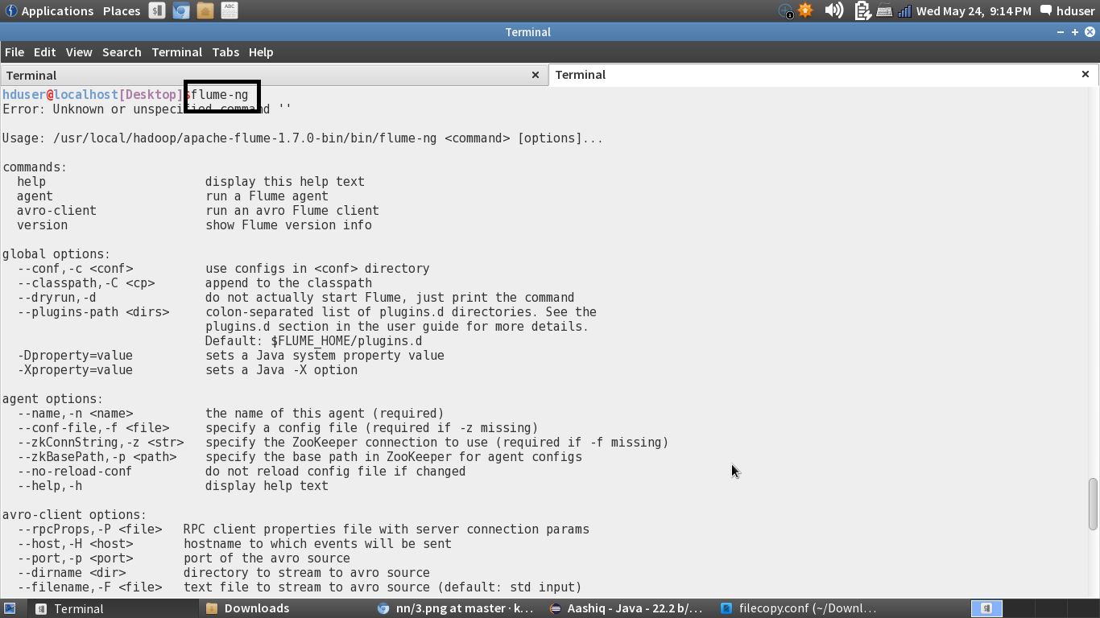

**Some of the Core Components in Flume-ng are:**

**Event:** A byte payload with optional string headers that represent the unit of data that Flume can transport from it’s point of origination to it’s final destination.

**Flow:** Movement of events from the point of origin to their final destination is considered a data flow, or simply flow.

**Client:** An interface implementation that operates at the point of origin of events and delivers them to a Flume agent.

**Agent:** An independent process that hosts flume components such as sources, channels and sinks, and thus has the ability to receive, store and forward events to their next-hop destination.

**Source:** An interface implementation that can consume events delivered to it via a specific mechanism.

**Channel:** A transient store for events, where events are delivered to the channel via sources operating within the agent.

**Sink:** An interface implementation that can remove events from a channel and transmit them to the next agent in the flow, or to the event’s final destination.

Creating a directory named ‘flume_import’ using mkdir command:

We will copy the dataset to this directory for further analysis.

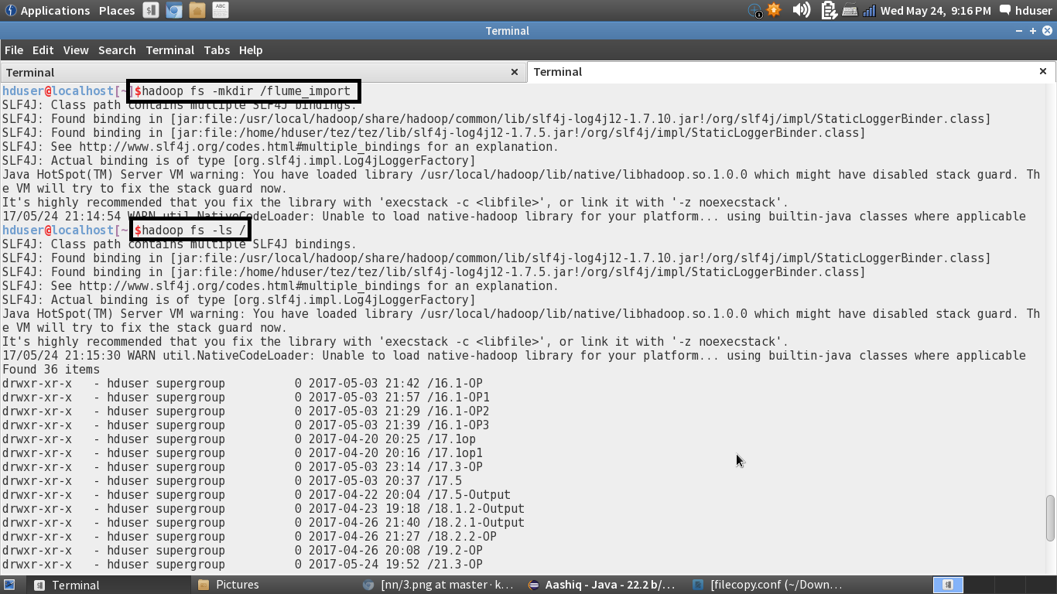

The Directory is created in the HDFS:

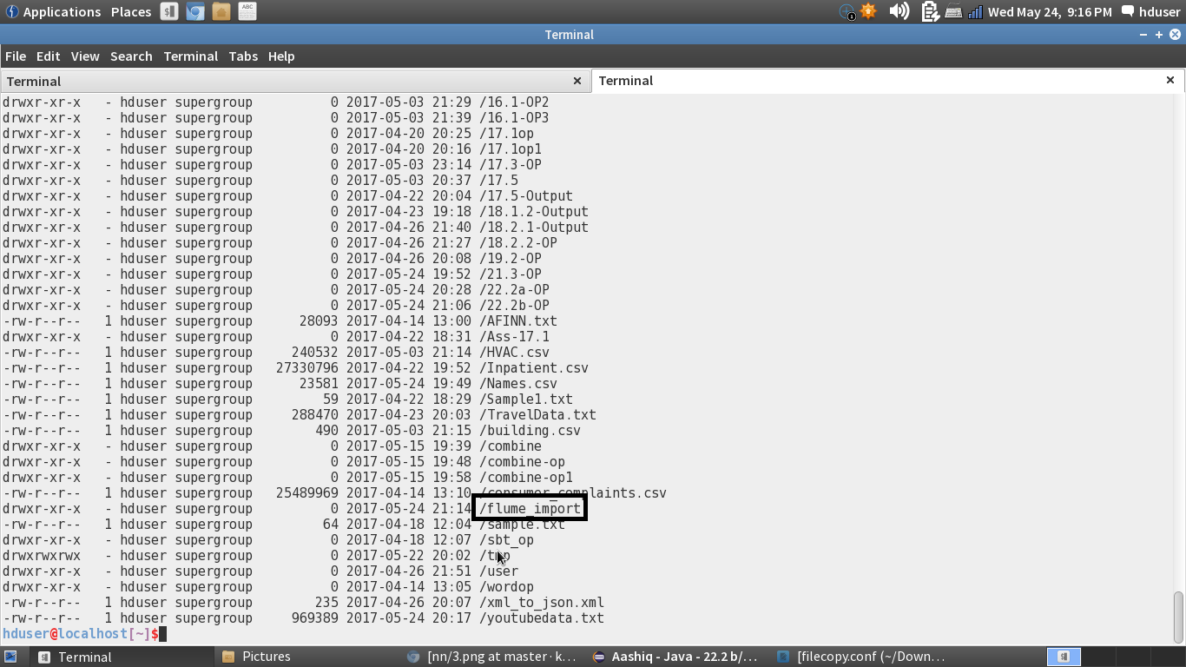

Creating a configuration file in the conf folder of the flume:

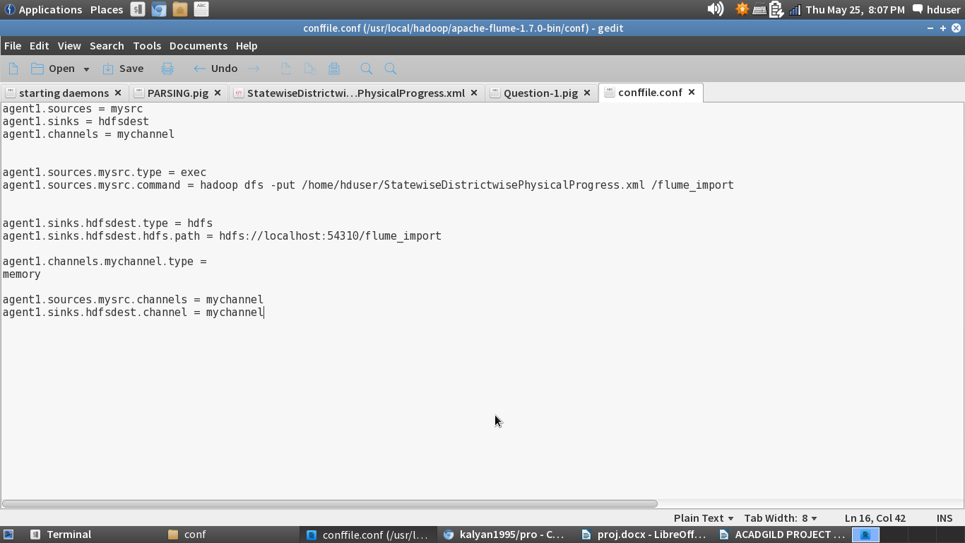

The put command is used to copy the file from local system to HDFS. That command is given in the configuration file. The HDFS path is also set in that file.

Flume Command: 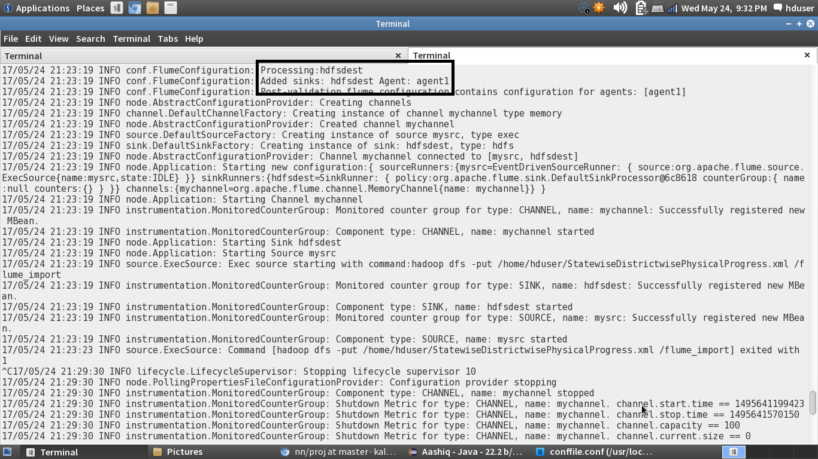

In the above screenshot, we are specifying the name of the agent which is agent1 and path to the configuration file is set



The flume_import directory is created and the input dataset is copied:

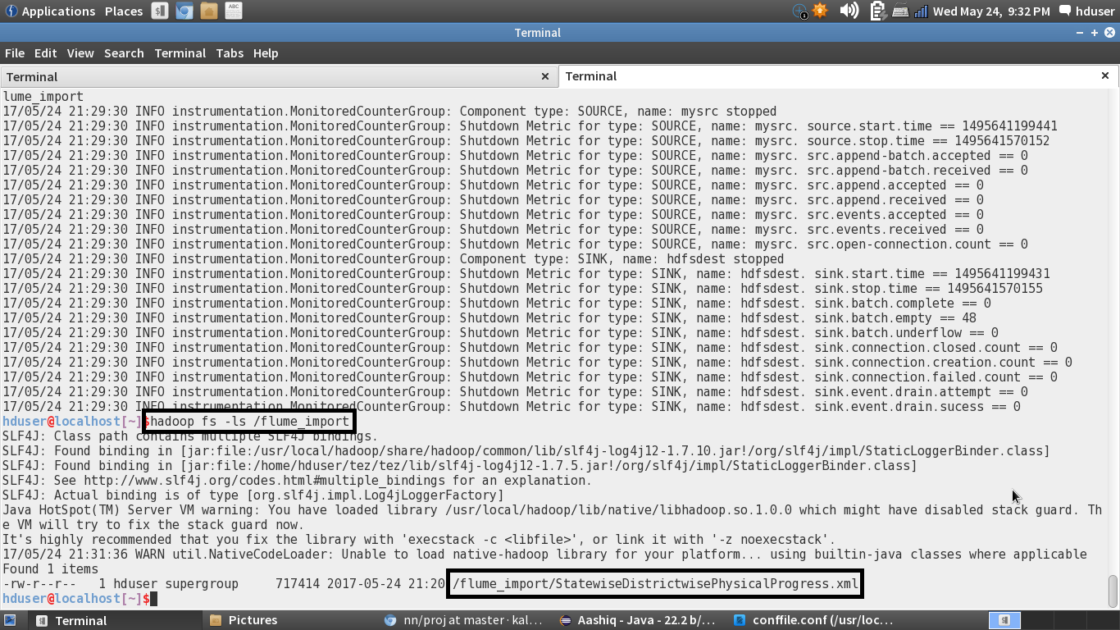

Displaying the sample input data file using cat command:

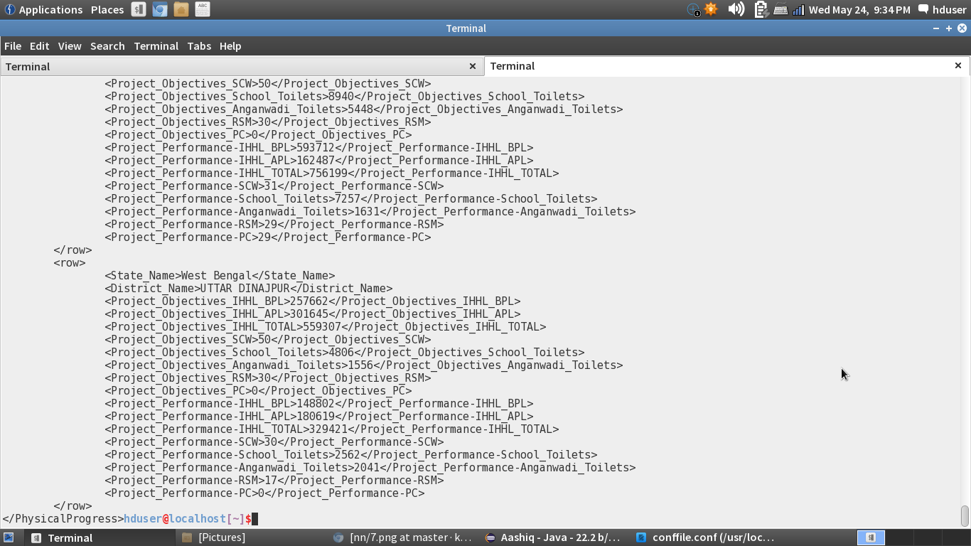

Parsing the input XML file:

Now the input data file is in xml file and it has to be converted to csv file. We will use a pig script to do that.

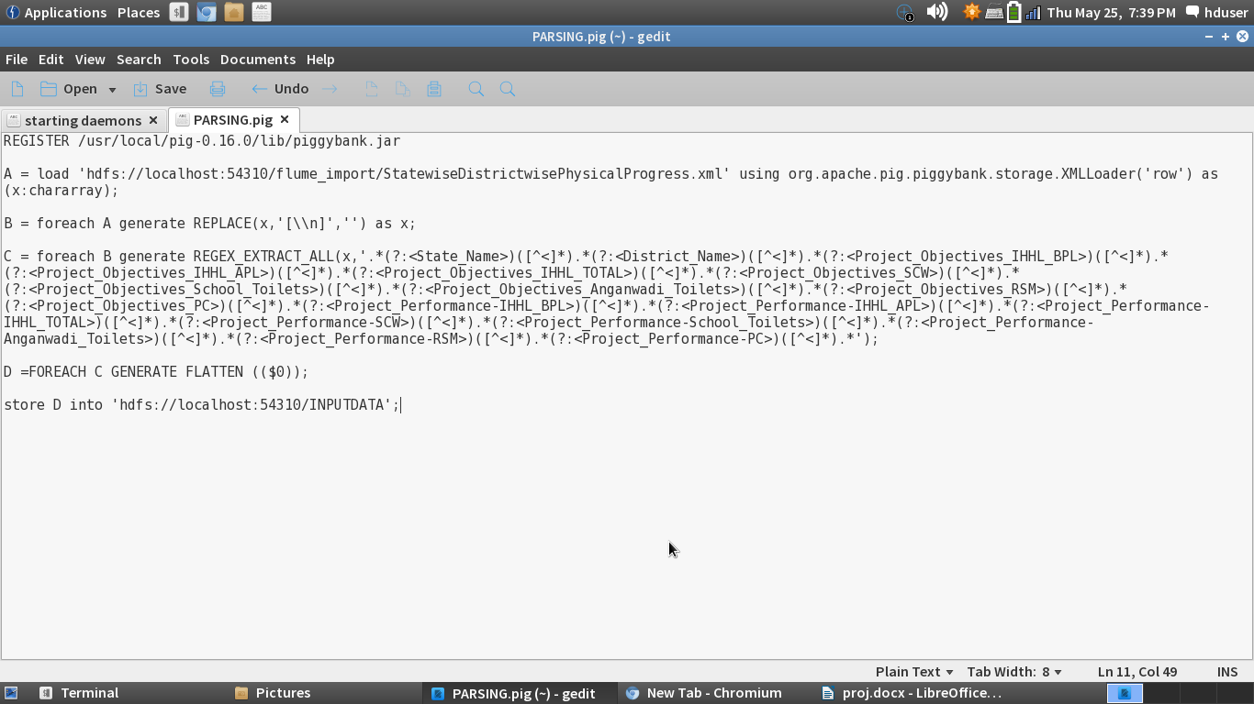

Step 1: Registering the piggybank jar

Step 2: Loading the dataset from the hdfs using the XMLLoader using chararray

Step 3: If there is a new line present in between the file, it will be removed.

Step 4: Use regex_extract_all function to capture values within tag.

Step 5: The Output will be in a bag and it is un nested using flatten command.

Step 6: Storing the output into hdfs for further analysis.

The above pig script is executed in the mapreduce mode. The Output of the data is stored in the ‘INPUTDATA’ folder.

The name of the pigscript is PARSING.pig

Executing the PigScript in mapreduce mode:

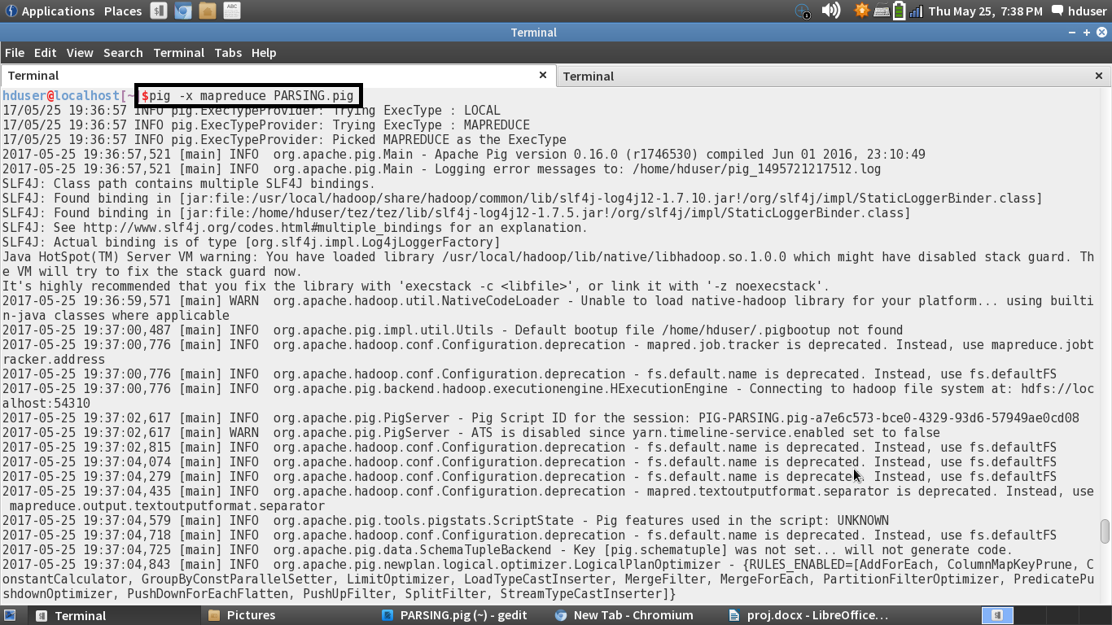

Output is successfully stored in the ‘INPUTDATA’ folder:

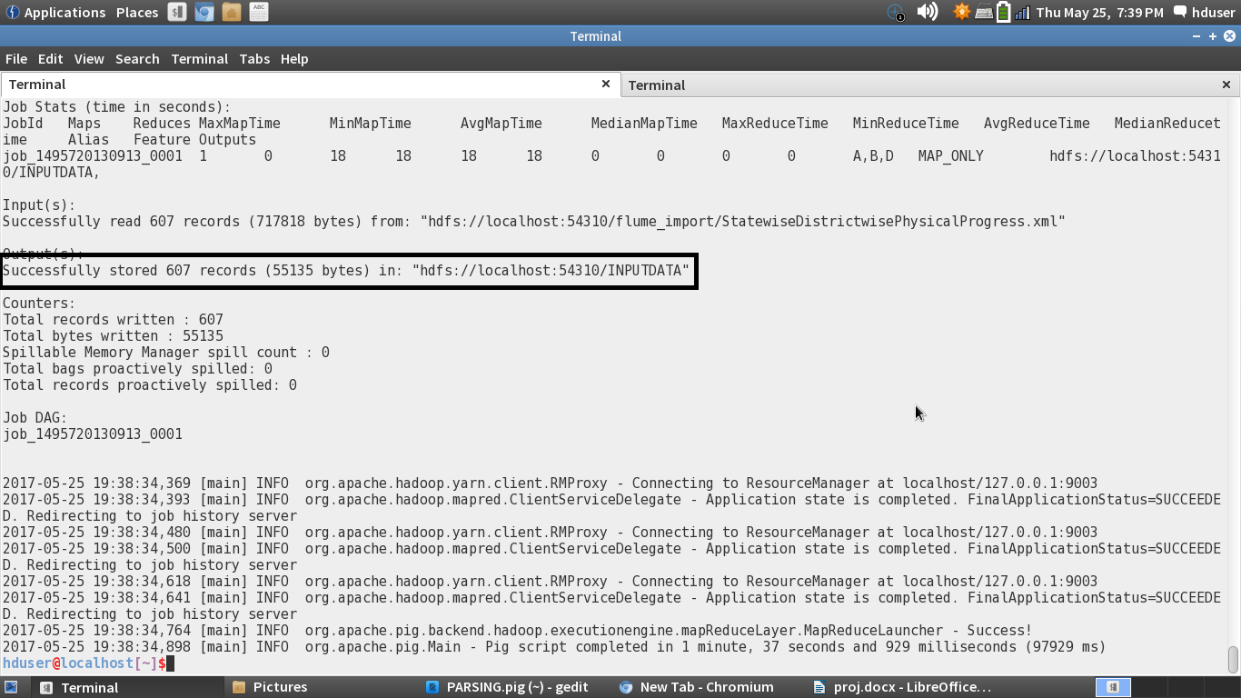

Displaying the parsed input data file(part-m-00000):

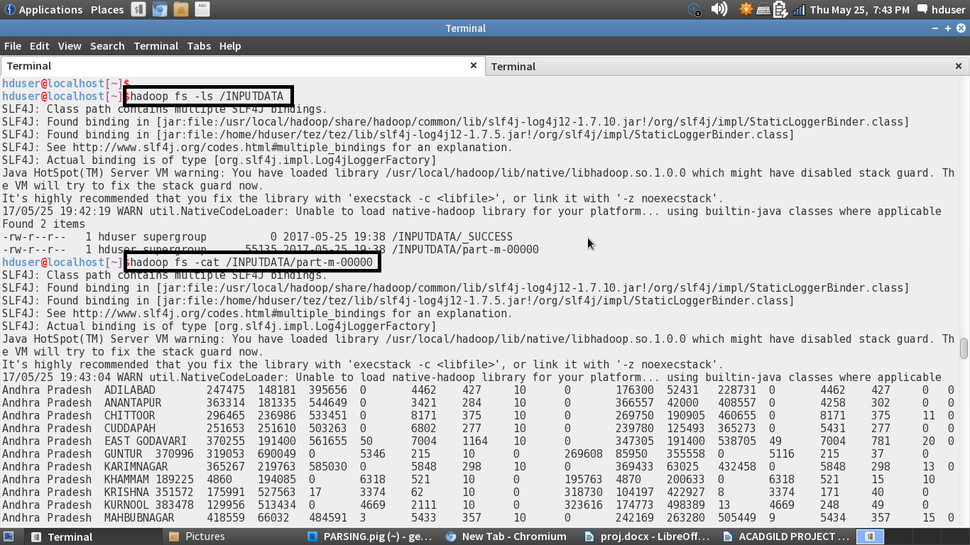

Sample data:

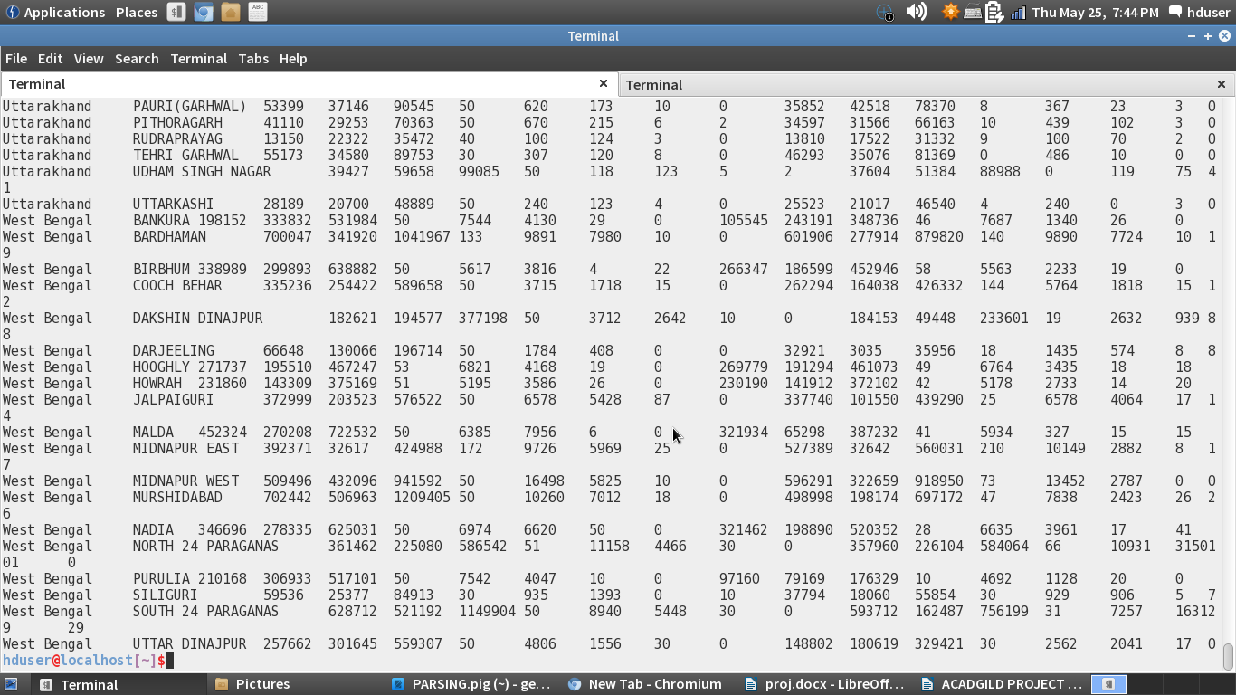

I uploaded the entire parsed data into the github for your reference.

Problem statement

Question 2:

1. Find out the districts who achieved 100 percent objective in BPL cards

Export the results to MySql using sqoop

Pig Script:

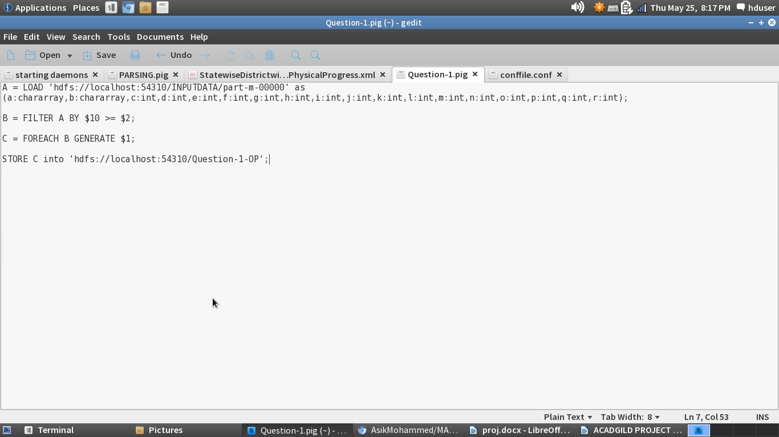

Step 1: Loading the parsed data

Step 2: We need the districts which achieved 100 percent objectives. 11th ($10) column is project performance and the 3rd ($2)column is project objective BPL. If the performance is higher than the objective, it is considered to be achieved 100 percent. We are using the filter command

Step 3: Since we need the districts we are only displaying the districts using the foreach generate command

Step 4: Storing the output in the hdfs.

The name of the script is Qusetion-1.pig. This Pig script file is attached in the github repository for your reference.

Executing the Pig Script in MapReduce mode:

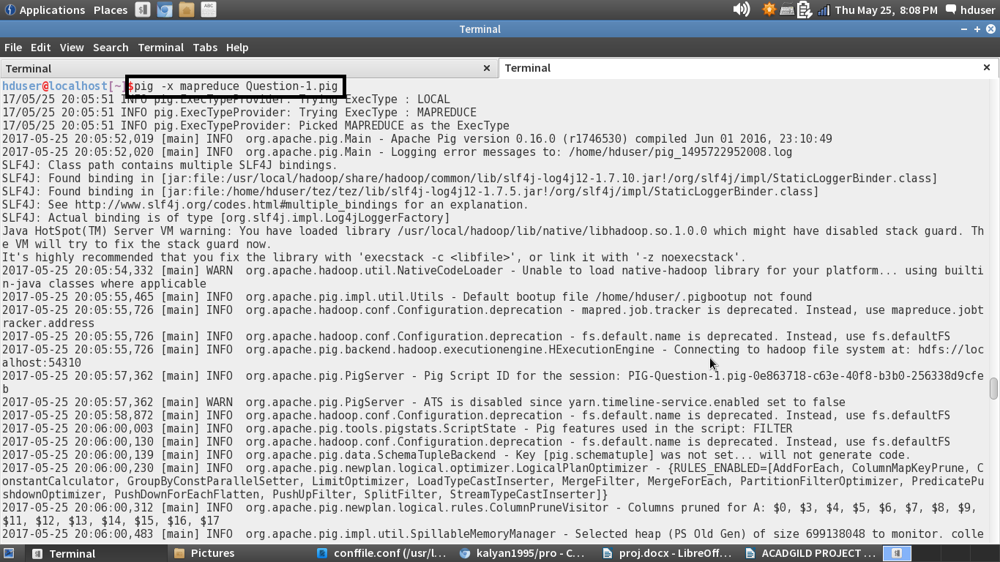

Output successfully stored in the hdfs:

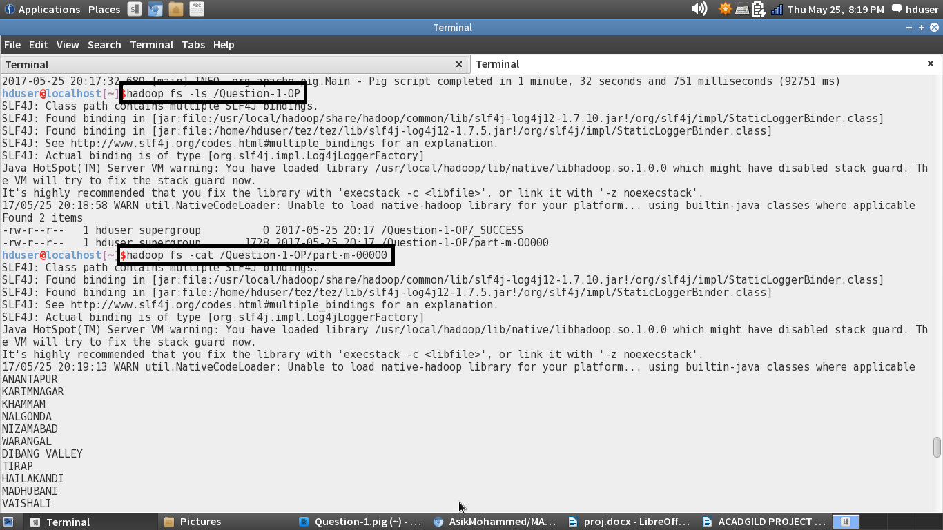

Sample Output:

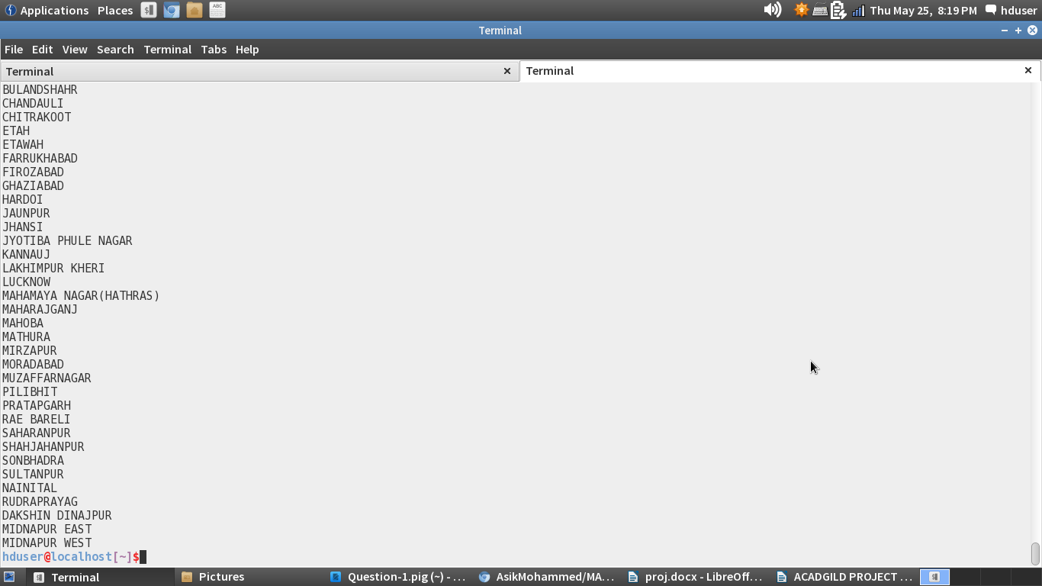

I have attached the complete output file in the github for your reference.

Exporting the Results to MySql:

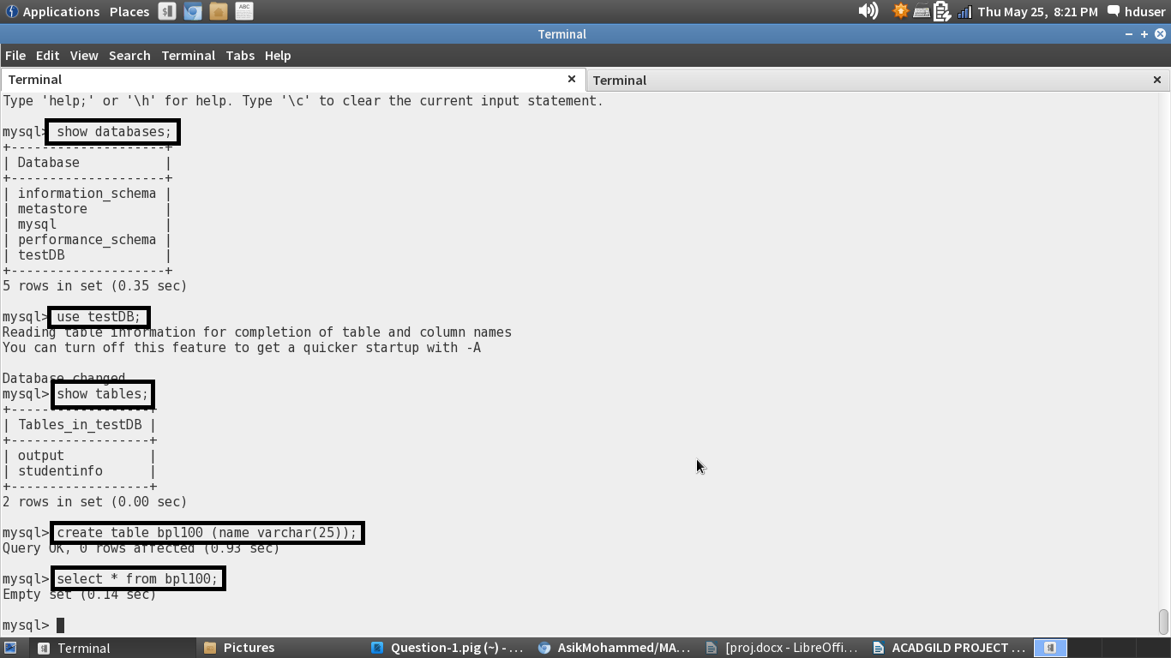

MySql terminal is opened and the database is selected and an empty table named bpl100 is created.

Before exporting the table will be empty.

Sqoop command to export from hdfs to Mysql:

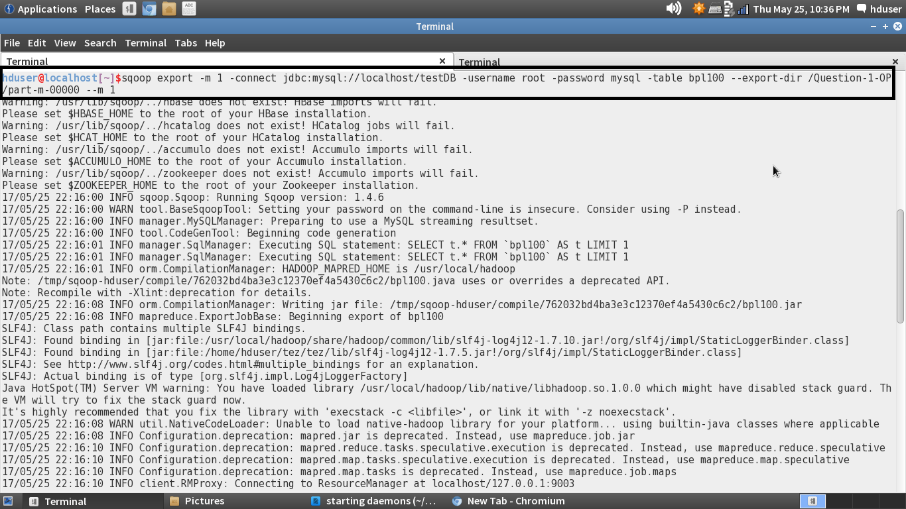

In the Command, we need to give the mysql database in which we created the table. The username and password to enter into the mysql are given in the command.

The hdfs output directory path and table name should also be set in the command. When the command is executed the sqoop will export the results from hdfs to the table in mysql.

Successfully transferred the records to the mysql:

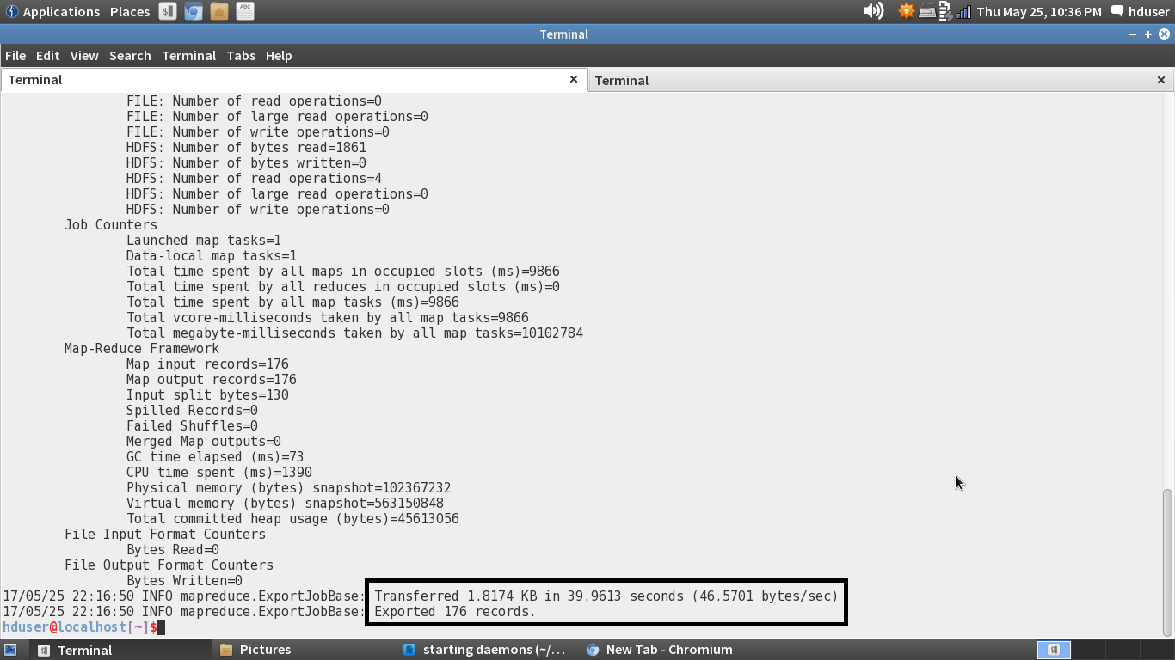

Displaying the contents of the ‘bpl100’ table:

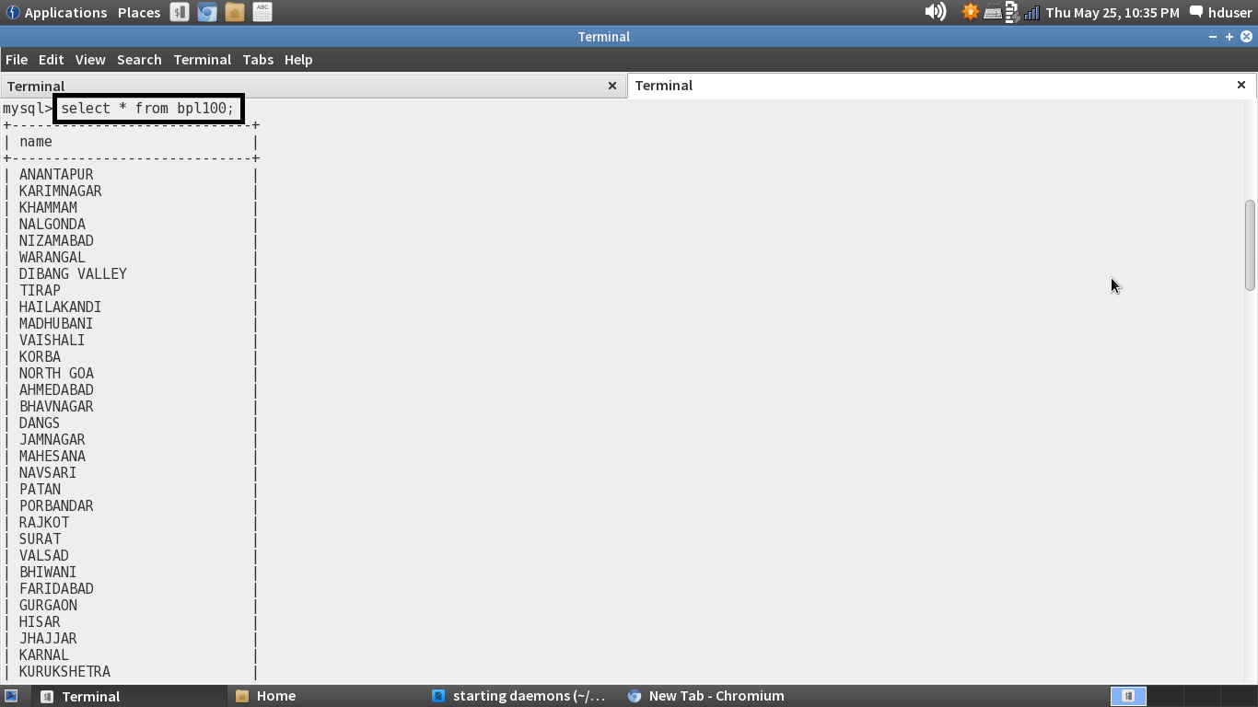

Question-2:

2. Write a Pig UDF to filter the districts which have reached 80% of objectives of BPL cards.

Export the results to MySQL using Sqoop

Creating a UDF to filter the districts:

Java Program:

Pig Script:

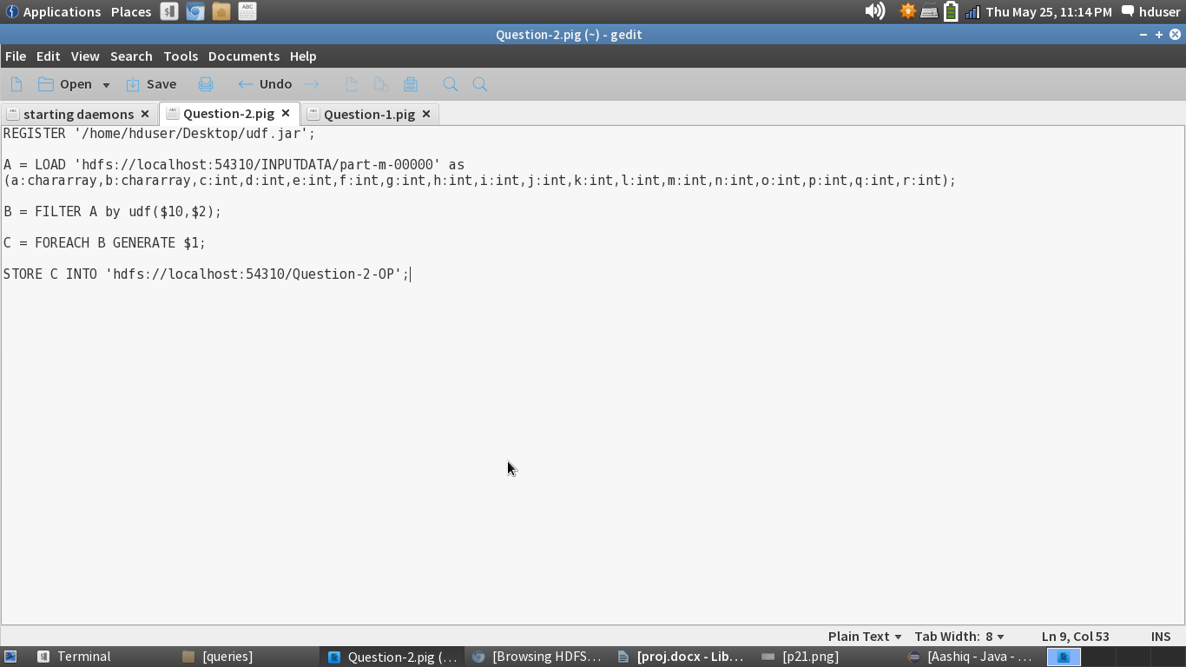

Step 1: The User defined function java program is exported to a jar file named udf, and this udf is registered.

Step 2: Loading the input data from hdfs

Step 3: Filtering the loaded input by the user defined function. Here we have to use the class name (udf) to filter.

Step 4: Since we need only the districts, we are taking the districts name using foreach generate.

Step 5: Storing the output in the hdfs.

The name of the pig script is Question-2.pig. This pig script file is attached in the github repository for your reference.

Executing the Pig Script in mapreduce mode:

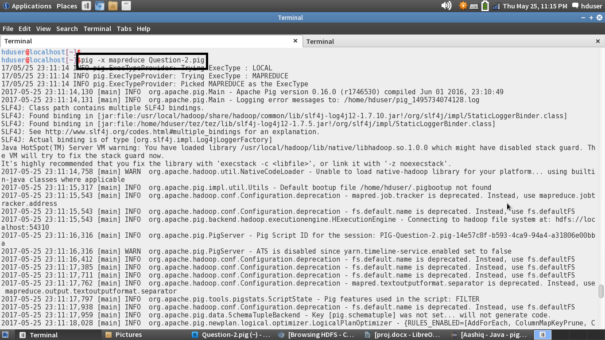

Successfully stored the output in hdfs:

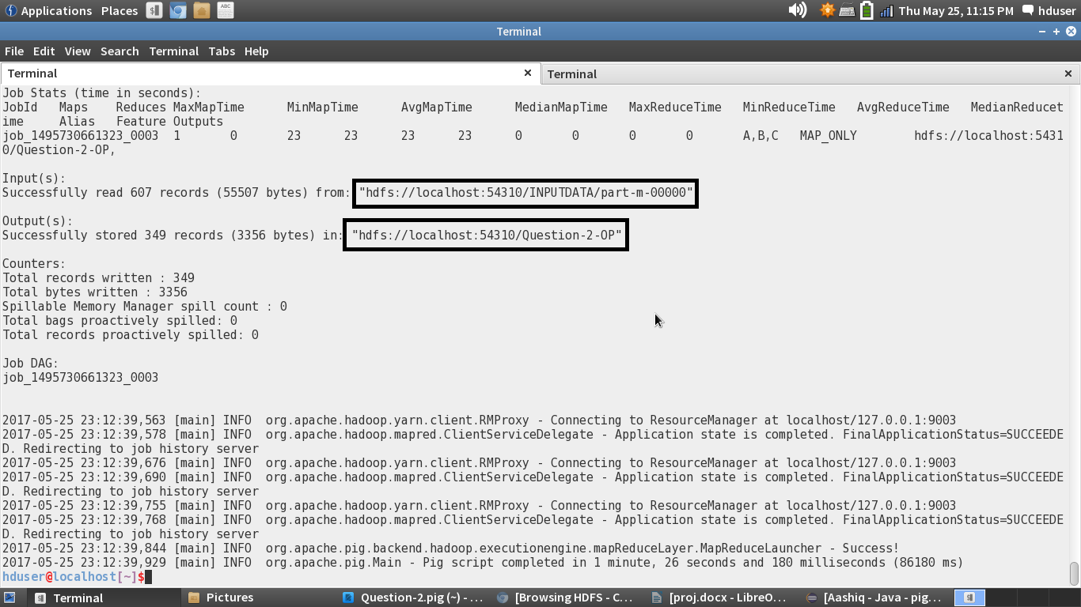

Checking the HDFS directory:

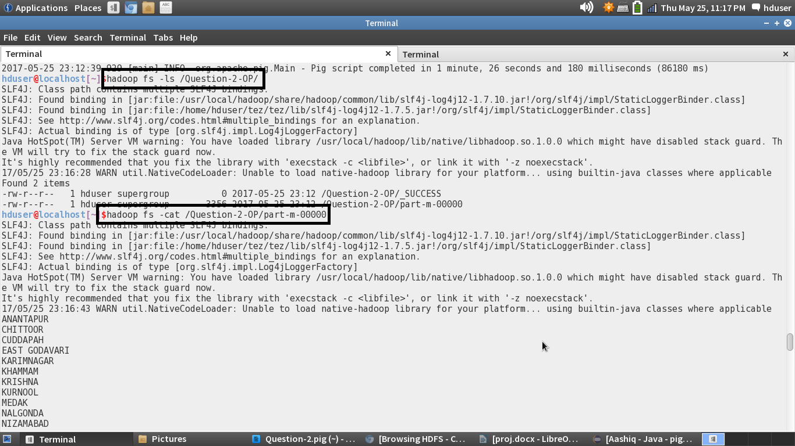

The pig script is successfully executed and the output is displayed using the cat command. The entire output is attached in the github repository.

Sample Output:

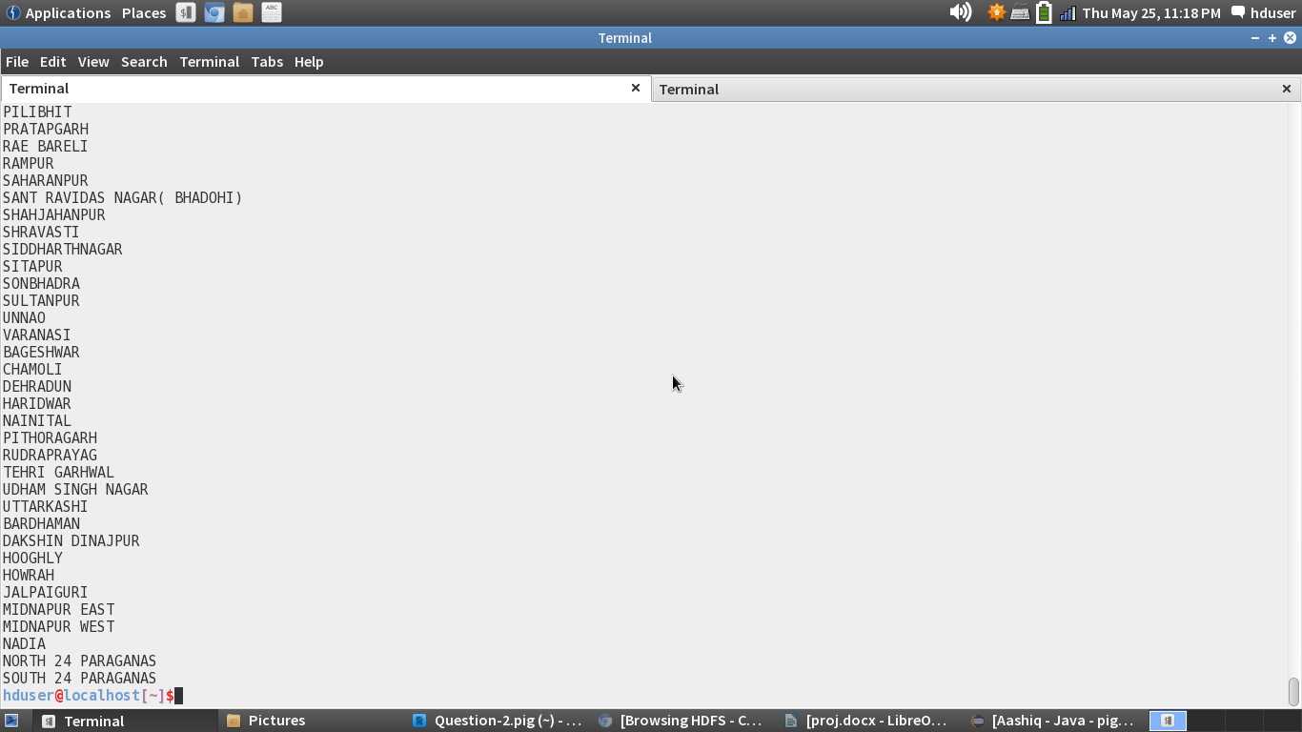

Exporting the output to mysql:

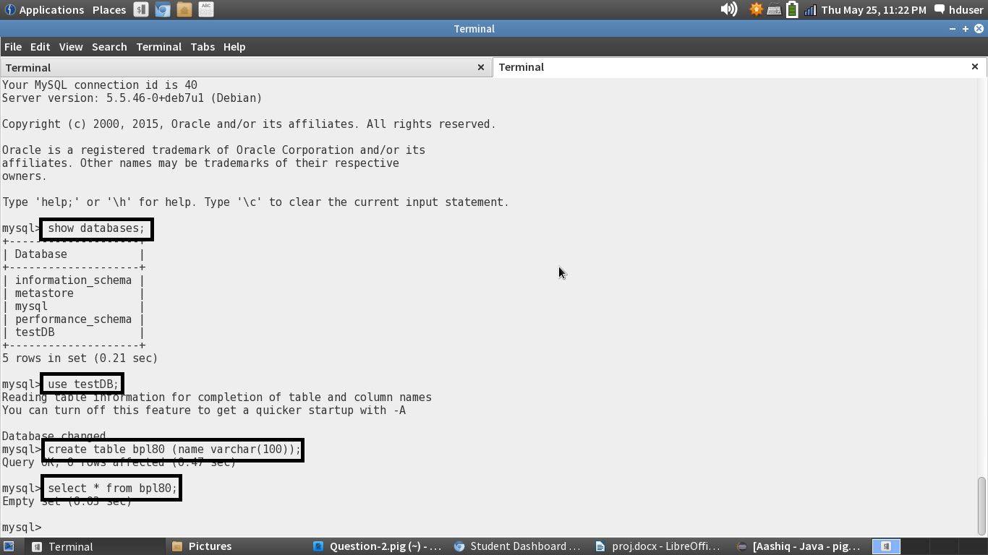

I am creating an empty table named blp80.

Sqoop Command to export the results to the mysql:

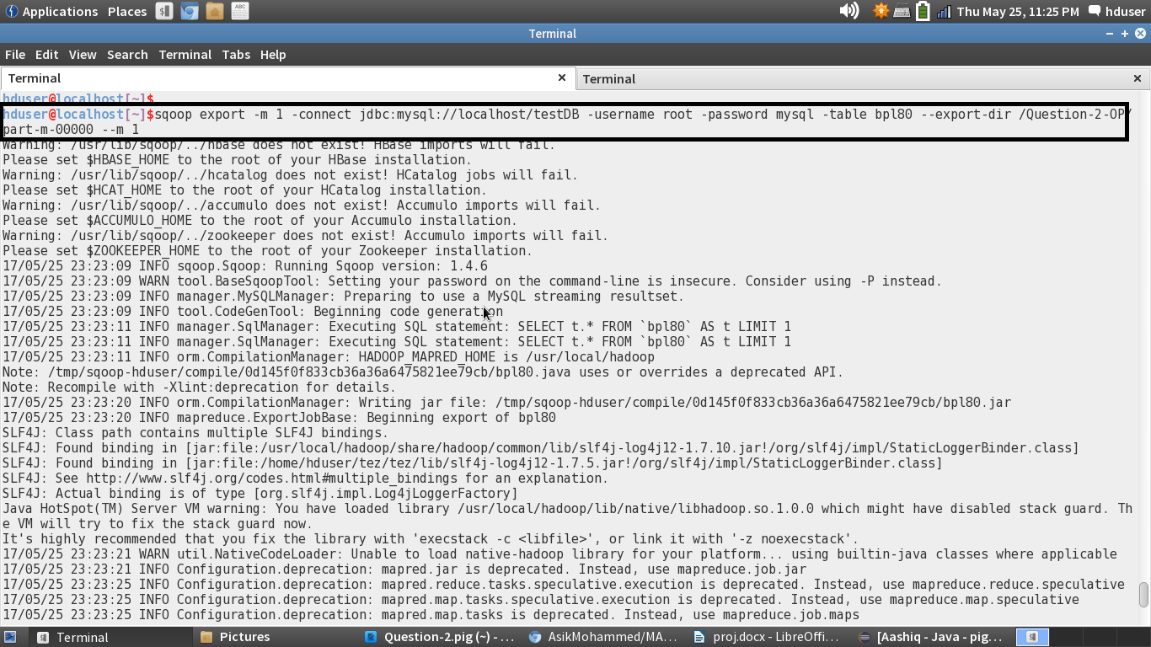

The hdfs directory path and the table names are provided in the command.

Successfully exported the results to mysql:

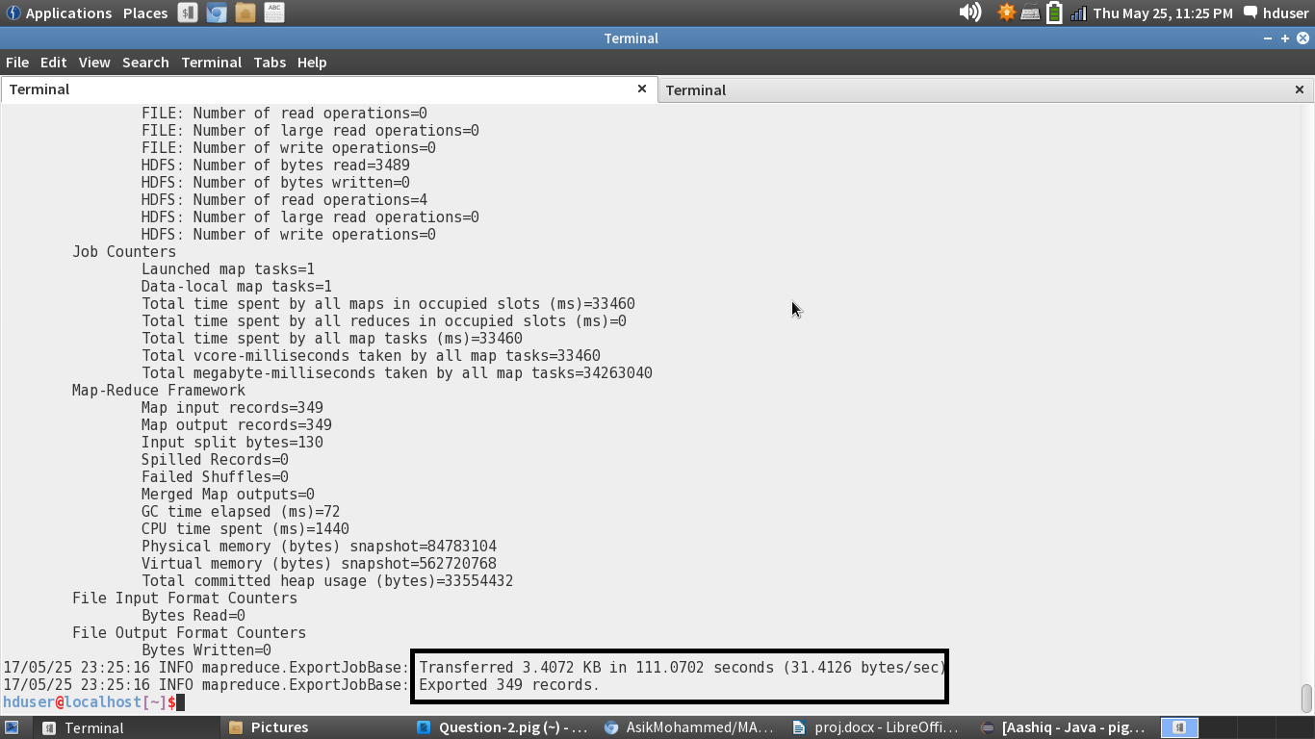

The Contents of the table is displayed:

